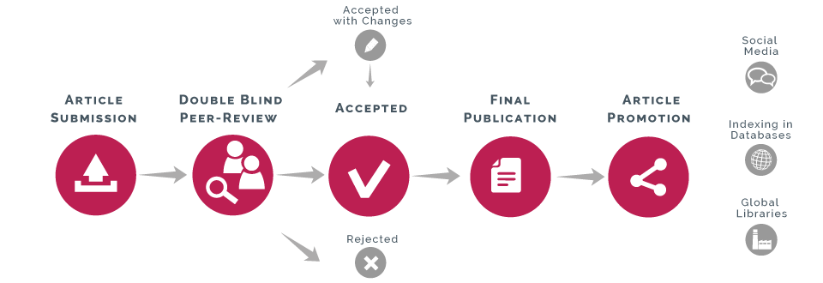**AUTHOR GUIDELINES**